**CS607 Assignment #2 Spring 2024**

Name: Abdul Rehman

VU-ID: BC220424444

**Solution of Define Membership Functions:**

First, we must simplify and summarize the tasks for designing the fuzzy inference system (FIS) for the intelligent AC system.

**Inputs:**

**Temperature (°C):**

* Low: Triangle (0°C, 15°C)
* Medium: Triangle (10°C, 30°C)
* High: Triangle (25°C, 40°C)

**Humidity (%):**

* Low: Triangle (0%, 30%)
* Medium: Triangle (20%, 70%)
* High: Triangle (60%, 100%)

**Number of Occupants:**

* Few: Triangle (0 persons, 2 persons)
* Moderate: Triangle (1 person, 5 persons)
* Many: Triangle (4 persons, 10 persons)

**Output:**

**AC Power Level (%):**

* Low: Triangle (0%, 40%)
* Medium: Triangle (30%, 70%)
* High: Triangle (60%, 100%)
* For Temperature:

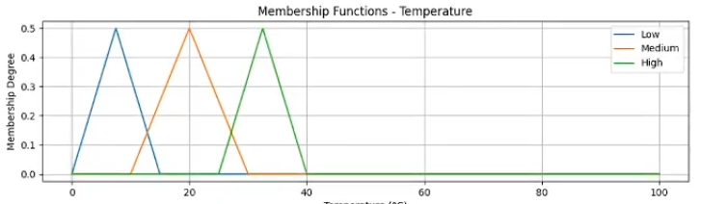

* For Humidity:

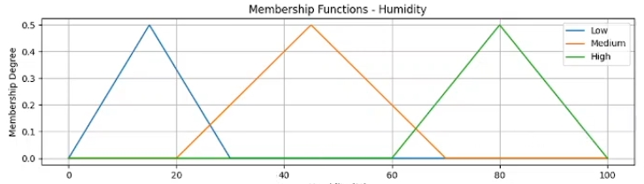

* For AC Power Level:

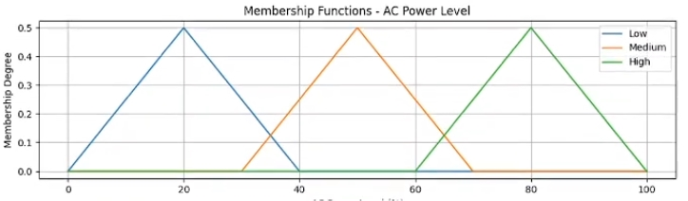

**Solution of Fuzzy Rules:**

* If Temperature is Low and Humidity is Low, then AC Power Level is Low.
* If Temperature is Medium and Humidity is Medium, then AC Power Level is Medium.
* If Temperature is High and Humidity is High, then AC Power Level is High.
* If Number of Occupants is Few, then AC Power Level is Low.
* If Number of Occupants is Moderate, then AC Power Level is Medium.
* If Number of Occupants is Many, then AC Power Level is High.

**Conclusion:**

These membership functions and fuzzy rules form the basis of fuzzy inference system for the intelligent AC system.

